**ASSIGNMENT 10.1**

1)Needs for Hive:

* It is used to for querying data stored in the Hadoop Distributed Filesystem (HDFS) in sql dialect.

* Since Most data warehouse applications are implemented using relational databases that use SQL as the query language.

* Hive lowers the barrier for moving these applications to Hadoop.

2)Is Hive suitable to be used for OLTP systems? Explain in brief:

* No, Hive does not provide insert and update at row level as it generally deals with large chumks of data.

* So it is not suitable for OLTP system.

3)What is a metastore in Hive?

* The Hive metastore service stores the metadata for Hive tables and partitions in a relational database.

4)Can we run unix shell commands from hive?

Give 5 examples and share the screenshot:

* Yes, it is possible to run unix shell commands form hive.

1

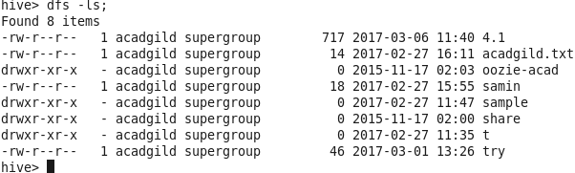

2

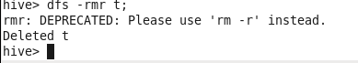

3 101.3.PNG

4 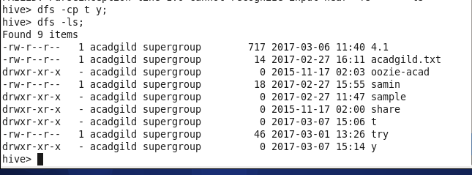

5 10.1.5.PNG

5)Hive can process any type of data formats? Explain in brief:

* Yes, Hive uses the SerDe interface for IO operations. Different SerDe interfaces can read and write any type of data.

* If normal directly process the data where as different type of data is in the Hadoop, Hive use different SerDe interface to process such data.